Can you name a breed that has been more successful than the Gaby Vandenabeele pigeon family in international races over 400 to 800km? Well, we can't.
No other pigon breed has given so many successful cracks as the noble Vandenabeele line, which has bred generations of pigeons that have excelled, dominated and conquered. This is what makes this pigeon breed stand out from the others, and it explains why the Vandenabeele pigeons are in such great demand. Pigeon fanciers from all around the world have visited the loft in Oentergem, not to take a sip from the holy fountain in Dentergem but to try and find the secret behind the Vandenabeele success story and their years of dominance, and to learn more about their pigeons.
Numerous fanciers were fascinated with the youngsters and even grandchildren of such iconic pigeons as Kleinen, Wittenbuik , and Bliksem, and the current generation of champions in Gaby's loft, including Rudy and his successful sons Super Romeo and New Bliksem, continue to receive widespread interest as well.

Gaby has had quite a spectacular career - his achievements are difficult to put into words. We assume almost every fancier is familiar with his enormous palmares, which has attracted widespread international media attention. Gaby and his wife Christine moved to their current home in the Wontergemstraat in Dentergem back in 1977, and no one could have guessed that this was the start of a most impressive career in pigeon racing. The first pigeons to be kept in Gaby's loft unsurprisingly came from his father Gentiel, who used to be a successful middle distance player in the province of West Flanders. Gentiel had created a breed based on pigeons of Valere Desmet­ Matthijs (Nokere) , Pol Bostijn (Moorslede) and Lucien Verstraete (Deinze). These were the type of pigeons Gaby could build on. These three bloodlines were destined to play a major role in the Gaby's pigeon loft, and they were represented by stock pigeons Kleinen, Bijter and Groten. The most important pigeon in the early development of this successful breed was 'Kleinen' BE81-3238253. 35 years later his impressive breeding qualities can still be found in today's racing team. In fact, all of Gaby's international stars are related to this pigeon, whether it be Wittenbuik , Bliksem, Rudy or the new generation. They have turned Gaby Vandenabeel e into one of our sport's grandmasters , a true pigeon racing hero!

This team's impressive achievements have attracted many people to Dentergem. This is the price of success. Friends, relatives, journalists, and visitors from all around the world have made the trip to the Vandenabeele loft in Oentergem . They get a steady stream of phone calls and emails, and we wonder where Gaby and his wife Christine find the energy to keep going every weekend. How does Gaby manage to maintain his level of performance despite the pressure? Fortunately, his daughter Ilse has recently decided to join the team! She is in charge of the organisation and the administrative side of GabyPigeons, which means Gaby can spend more time in the pigeon loft. The next step would be to get Ilse involved in the loft as well ...

Gaby got familiar with pigeon racing at the highest level at an early age, spending a lot of time in the loft of his father Gentiel, who was a successful fancier himself.
The pigeon collection and the invaluable experience that he got from his father proved an excellent starting point for Gaby when he started keeping pigeons in 1976.
Gaby quickly started to dominate the local middle distance competition like a grandmaster. In fact, he did so well that many of his opponents decided to leave the region to join a different competition instead. Dentergem became a place that many neighbouring pigeon clubs stayed away from. This was of course a sad development , and eventually Gaby had no choice but to bid farewell to the middle distance competition in 1985. He switched to a different competition , aiming instead on the provincial and national races of the longer middle distance and the extreme long distance (400-800km). The fanciers that forced Gaby to leave the middle distance competition have in fact enabled the Vandenabeele pigeons to become an internationally renowned breed, ready to join our sport's hall of fame. His first major achievements followed soon: his spectacular racing team put in its first great effort in 1985, winning a 2nd and 10th national in the national race from Limoges in early July. The pigeon that had to settle for second place was Fideel, a son of Kleinen. It was just a matter of time before Gaby would claim a national first prize! Gaby eventually won his first national victory in 1988, when 'Rambo' took a national first prize from Bourges against 13,154 old birds. He also was the fastest bird of the 63,176 pigeons in total on that flight. It would be the first of seven consecutive national victories. This was the starting point for a spectacular and long-standing career. The year 1988, when the now legendary Wittenbuik hatched from its egg, marked the rise of the dynasty of the illustrious Kleinen, his son Wittenbuik and his grandson Bliksem. Together they have made history in our sport. Kleinen became the leading man in this loft and the stock sire of a bloodline with an international reputation ; a bloodline with truly exceptional breeding qualities. This pigeon laid the foundation for a team that won 7 national first prizes and 97 provincial first prizes between 1988 and 2014. The national victories can be found below:

1st National Bourges | 13,154 olds | 1988
1st National Limoges | 8,883 olds | 1995
1st National Brive | 4,719 olds | 1995
1st National Brive | 3,970 2yr | 1995
1st National Bourges | 13,166 yrls | 2002
1st National Argenton | 7,358 olds | 2010
1st National Tulle | 5,731 yrls | 2014

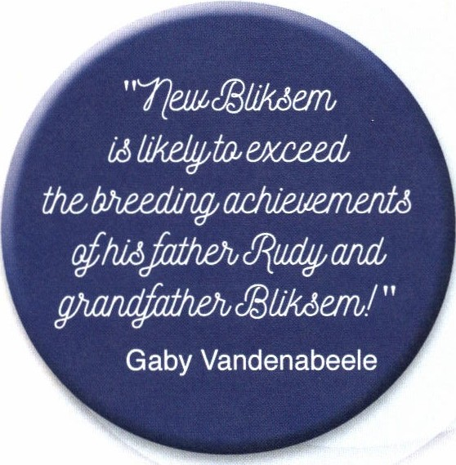

Does Gaby Vandenabeele have something other fanciers don't? Does he know more than some of his opponents? He has really been able to push his pigeon breed to a higher level. He has always managed to find that one stock sire or top quality breeding pigeon to build a team around. Is it simply a matter of luck or does he have a special feel for pigeons? For instance, he firmly believes that New Bliksem is capable of exceeding the achievements of his sire Rudy and grandfather Bliksem in the breeding loft. Only time will tell, but we do know that Gaby does not make many mistakes. It is also worth noting that Gaby's most important pigeons are all directly related to Kleinen. The impressive legacy of stock sire 'Kleinen', his son 'Wittenbuik ' and his grandson 'Bliksem' is now continued through the lines of 'Rudy', 'Super Romeo' and 'New Bliksem'. This means that their breeding talents have been passed on to future generations .

Gaby has always believed that true top quality is at the heart of our sport. It is the foundation of every success story. Without it you cannot sustain a 35-year career at the top of our sport. Top quality is the result of strict selection! In fact, Gaby did not even have his own breeding pigeons in his first five years. Kleinen was the first real
breeding pigeon in Gaby's collection but he was one of a kind! Gaby does not keep pigeons in a golden cage; they first have to prove themselves . He really puts them to the test. He adopted this approach from his father Gentiel, who achieved great results throughout his career. He was very demanding towards his pigeons: they had to be on top of their game in demanding weather conditions, with speeds of 1200 m/min or less. Those that failed to deliver were dropped from the team. Strict selectioning was the key to success and Gaby has adopted this strategy as well : his best champions were selected in races with hard weather, with speeds of 1300 m/min or less (wind still
or headwind). Pigeon racing is all about prize winners , and it takes strong pigeons to win top prizes. These pigeons can only be found in races with a strong headwind, where pigeons can break away from the group to claim victory. Gaby gives his pigeons the chance to prove themselves in the breeding loft at an early age, as was also the case with Wittenbuik (3 x 1st interprovincial), Bliksem and Rudy, and now Super Romeo and New Bliksem as well. Gaby is always looking for possible reinforcements. He uses the same strategy when purchasing new pigeons; he looks
for pigeons that can excel in tough weather conditions. In addition, they should be originating from pigeons with excellent breeding qualities. Their descendants are put to the test in different races first before being introduced in the existing breed. In addition Gaby favours pigeons with a soft plume, with small and elongated primaries and a medium sized shape, even though some of his best stock pigeons are called Kleinen (small one) and Groten (big one). Still, medium-sized pigeons are the best choice, as they require fewer compensation pairings.

